Hidden form fields session tracking technique is nothing but working with hidden boxes of the form page to remember the client data across the multiple requests and to make the application as the stateful web application.

How to make the hidden form fields:

===========================

<input type=’hidden’ name=’-‘ value=’-‘/>

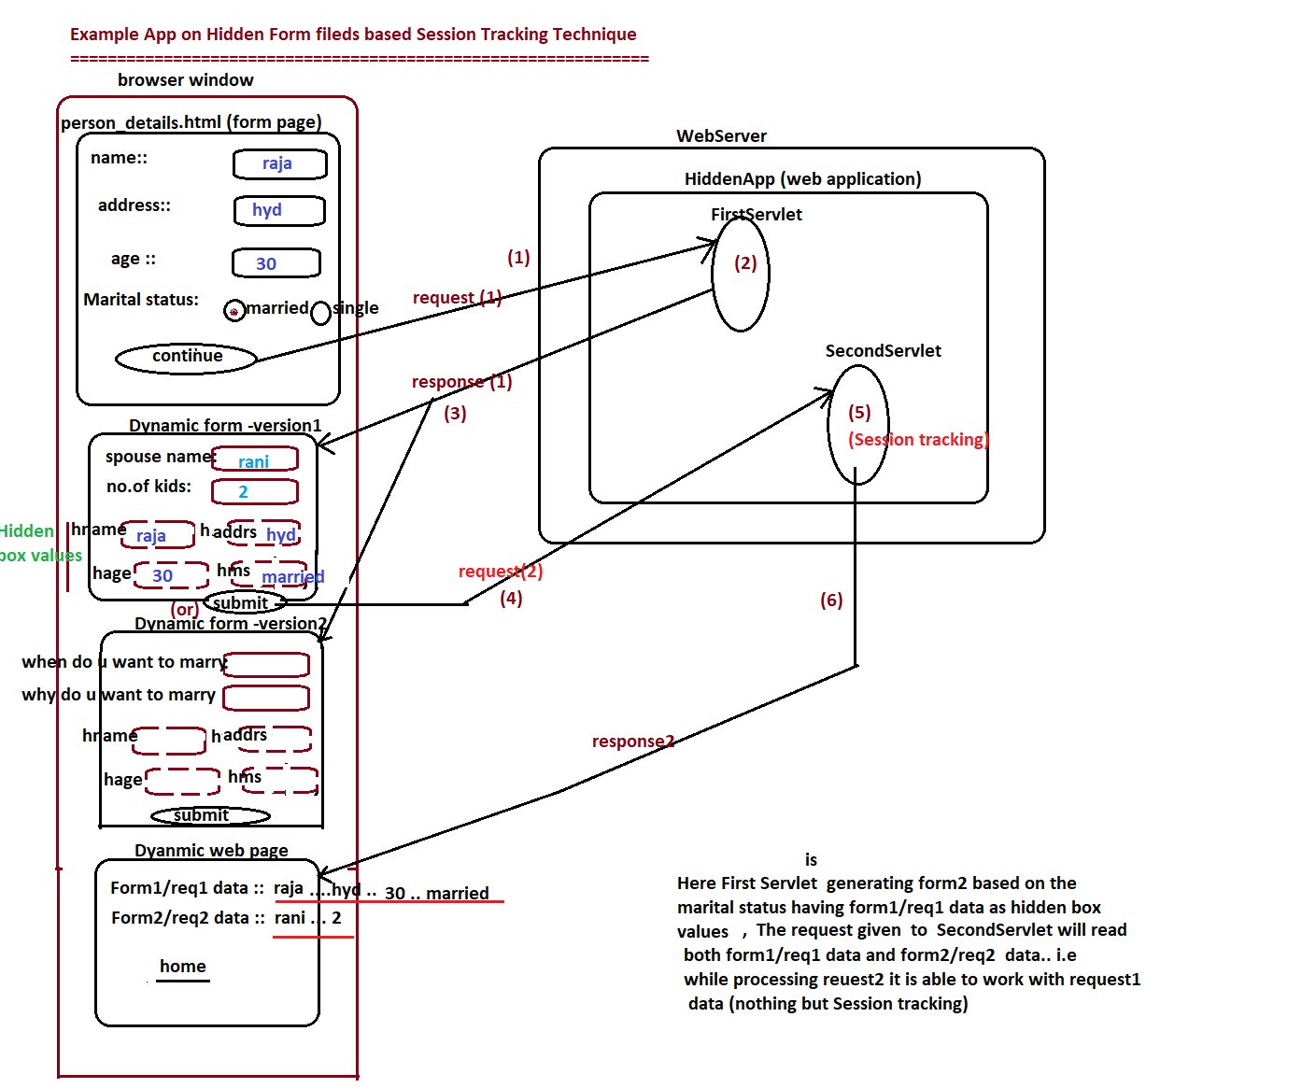

Project Directory Structure:

===================

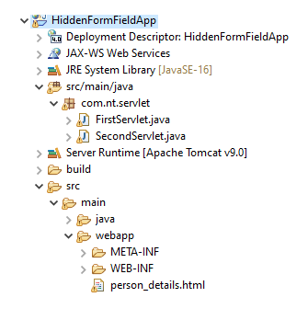

Person_details.html

==============

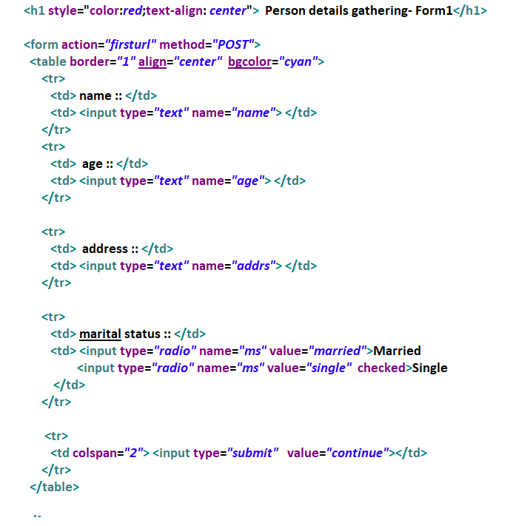

FirstServlet.java

============

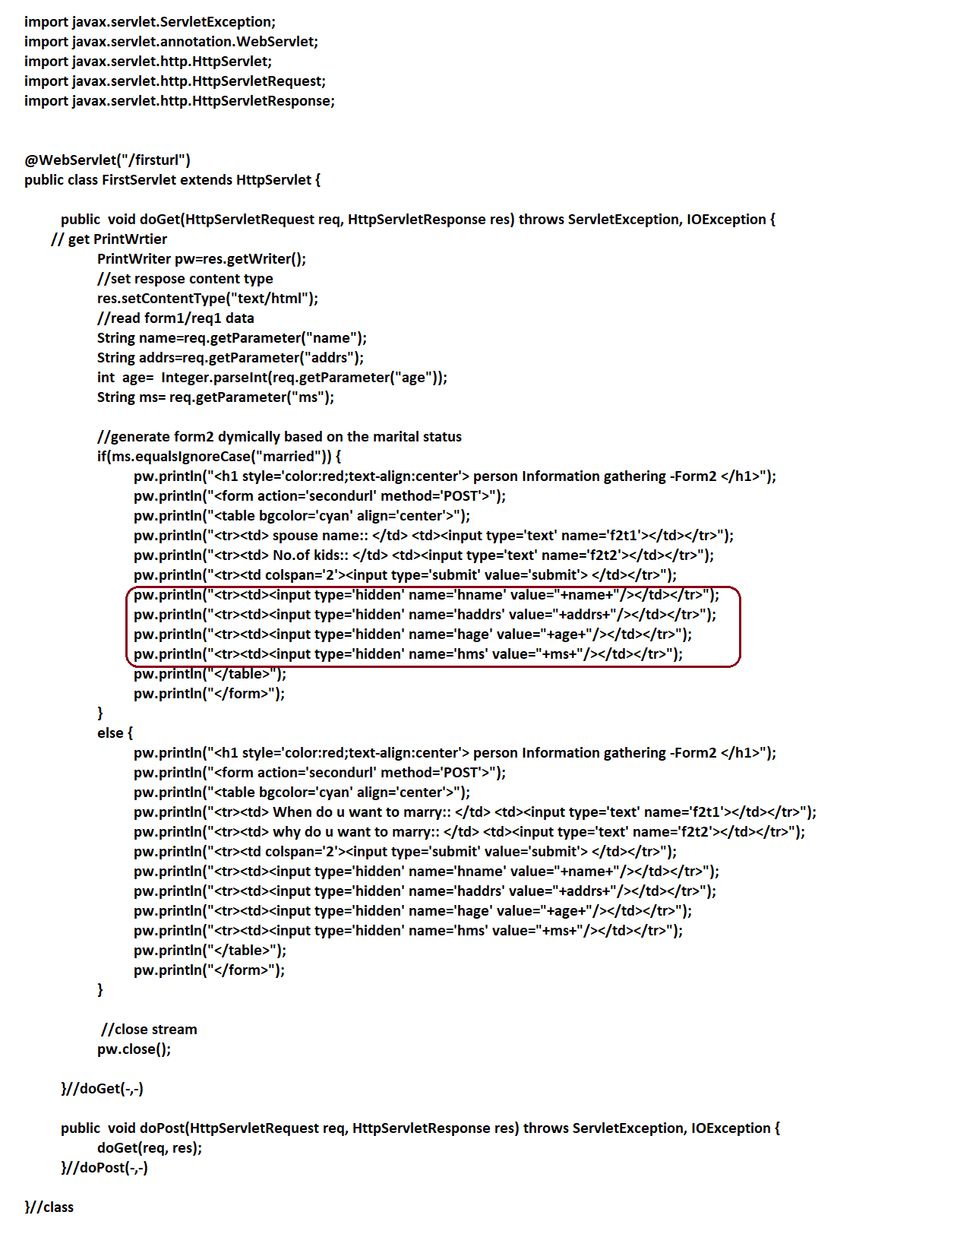

SecondServlet.java

==============

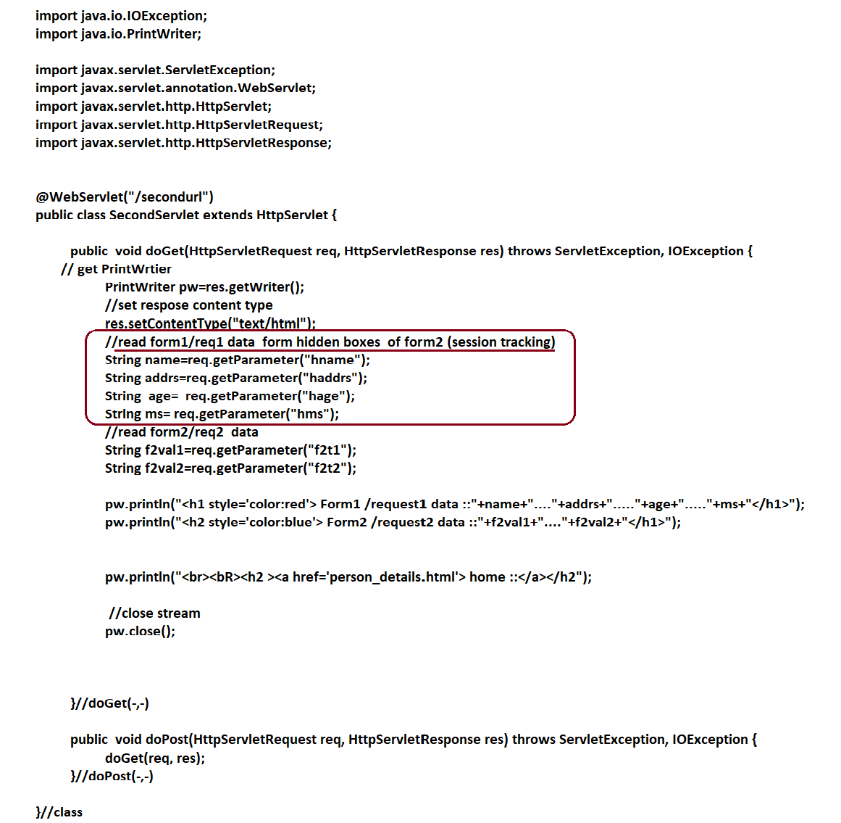

Pros (Advantages) of hidden form field technique:

====================================== ========

1. This technique work in all web servers and application servers.
2. This technique work in all serside web technologies.(both java and non-java)
3. This technique needs basic HTML knowledge.

Cons (di sAdvantages) of hidden form field technique:

======================================

1. There is no data secrecy because we can see hidden boxes data.

View🡪 source option of browser.

1. Hidden boxes can only text data(i.e we can not place all kinds of java object s init)
2. The data of hidden boxes travel along with request and response across the multiple requests ..so there will be network traffic between browser and web server.